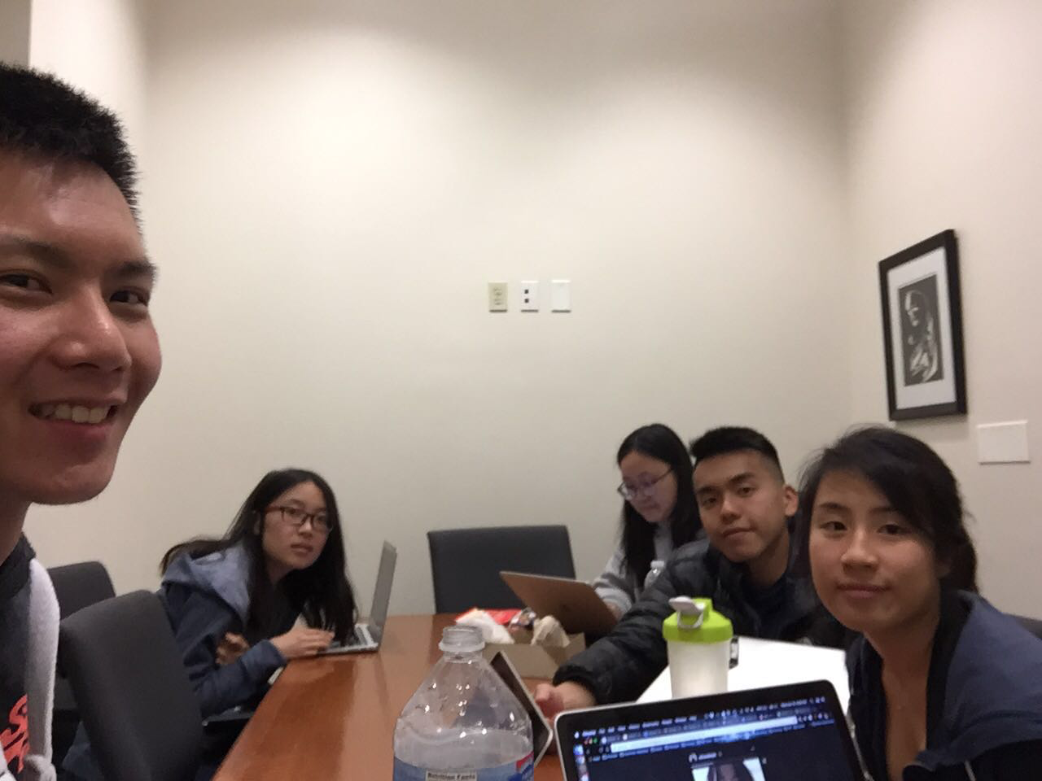

Allocated meeting time: April 18th, 9:00pm-10:00pm

Actual meeting time: April 18th, 9:00pm-10:00pm

Product owner: Professor Halfond, TAs, CPs

Scrum master: Gong Chen

Team members: Lingyi Li, Joann Lin, Peixuan Liu, Ryan To, Tuling Zhao

Scrum summary:

We discussed things we need to do for the last sprint after a review and retrospective meeting. We were dividing tasks for the third sprint.

1. What have you accomplished since the last meeting?
2. Are there any obstacles in the way of meeting your goal?
3. What will you accomplish before the next meeting?

Gong Chen:

1. Writing the Review and Retrospective document
2. None
3. Show error message when less than 30 images are found for a given input

Lingyi Li:

1. Wrote Review and Retrospective document
2. None
3. Start to write sprint 3 process report

Joann Lin:

1. Wrote Review and Retrospective document. Implemented export functionality
2. None
3. Fix save collage functionality and add save collage deletion

Peixuan Liu:

1. Communicated with stakeholders about requirements
2. None
3. Add more white-box tests

Reason for absence: Personal issues

Ryan To:

1. I will fix the blackbox test cases from sprint 2’s review. This includes adding more test cases for filtering images, logging in with different users and displaying the error when insufficient images are found.
2. Nothing.
3. I will fix at least 2 out of the 3 blackbox test cases by the next scrum meeting.

Tuling Zhao:

1. Wrote review and retrospective document
2. None
3. Change layout of main.jsp